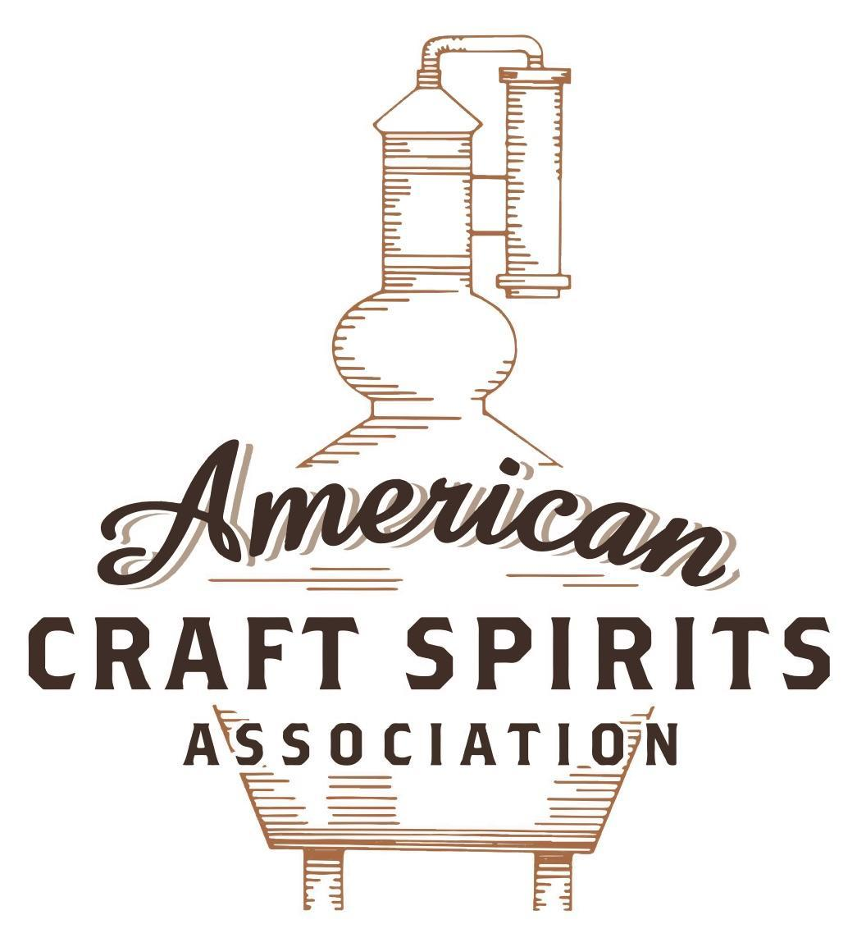
Spirits DtC Shipping Guide

This guide summarizes the direct-to-consumer shipping rules for distilleries in all 50 states and D.C. and also addresses the measures state governments have taken to ease delivery and shipping restrictions during the COVID-19 pandemic.

DtC Quick Guide Comparison

Out-of-State Distilleries  Can Ship Into State? |  |  |  | In-State Distilleries  Can Ship Within State?
State | Yes | No |  | State | Yes | No
AL |  | X |  | AL |  | X
AK | X |  |  | AK | X
AZ | X |  |  | AZ | X
AR |  | X |  | AR |  | X
CA |  | X* |  | CA |  | X*
CO |  | X |  | CO |  | X
CT |  | X* |  | CT |  | X
DE |  | X |  | DE |  | X
DC | X |  |  | DC | X
FL |  | X |  | FL |  | X
GA |  | X |  | GA |  | X
HI |  | X* |  | HI |  | ?*
ID |  | X |  | ID |  | X
IL |  | X* |  | IL |  | X*
IN |  | X |  | IN |  | X
IA |  | X* |  | IA |  | X*
KS |  | X |  | KS |  | X
KY | X |  |  | KY | X
LA |  | X |  | LA |  | X
ME |  | X* |  | ME |  | X*
MD |  | X |  | MD |  | X
MA |  | X |  | MA |  | X
MI |  | X |  | MI |  | X
MN |  | X |  | MN |  | X
MS |  | X |  | MS |  | X
MO |  | X |  | MO |  | X
MT |  | X |  | MT |  | X
NE | X |  |  | NE | X
NV |  | X* |  | NV |  | X
NH | X |  |  | NH |  | X*
NJ |  | X* |  | NJ |  | X*
NM |  | X |  | NM |  | X
NY |  | X* |  | NY |  | X*
NC |  | X |  | NC |  | X
ND | X |  |  | ND | X
OH |  | X |  | OH |  | X
OK |  | X |  | OK |  | X
OR |  | X |  | OR | X
PA |  | X* |  | PA |  | X
RI |  | X* |  | RI |  | X
SC |  | X |  | SC |  | X
SD |  | X |  | SD |  | X
TN |  | X |  | TN |  | X
TX |  | X |  | TX |  | X
UT |  | X |  | UT |  | X
VT |  | X |  | VT |  | X
VA |  | X |  | VA |  | X
WA |  | X* |  | WA | X
WV |  | X* |  | WV |  | X*

WI |  | X |  | WI |  | X
WY |  | X |  | WY |  | X

Notes:
*CA: If passed and signed into law, Senate Bill 620 would allow licensed distilled spirits producers in states other than California and licensed distilled spirits manufacturers or craft distillers in California who obtain distilled spirits direct shipper permits to ship directly to consumers in California
*CT: Consumers with appropriate permit may receive alcohol shipments
*HI: Consumers with appropriate permit may receive alcohol shipments; If passed and signed into law, Senate Bill 65 would allow licensed distilled spirits manufacturers in Hawaii and in states other than Hawaii who obtain direct shipper permits to ship directly to consumers in Hawaii
*IL: If passed and signed into law, Senate Bill 0532 would allow licensed distilled spirits producers in Illinois and in states other than Illinois who obtain distillery shippers’ licenses to ship directly to consumers in Illinois
*IA: If passed and signed into law, House File 639 would allow native distilled spirits manufacturers in Iowa and in states other than Iowa who obtain direct shipper permits to ship directly to consumers in Iowa and to consumers in states other than Iowa
*ME: If passed and signed into law, Legislative Document 1358 would allow distilleries outside of Maine with current manufacturer licenses and distilleries licensed in Maine who obtain spirits direct shipper licenses to ship directly to consumers in Maine
*NJ: (1) If passed and signed into law, Assembly Bill 3167 would allow a craft distillery licensees to ship no more than 9 liters of distilled spirits to a consumer in New Jersey; (2) If passed and signed into law, Senate Bill 3020 would allow craft distillery licensees in New Jersey or in states other than New Jersey to ship no more than 20 liters of distilled spirits to a consumer in New Jersey via common carrier
*NV: Licensed individuals can import one gallon per month of spirits for personal use and the out-of-state supplier must pay excise tax
*NH: If passed and signed into law, Senate Bill 125 would allow licensed liquor manufacturers who obtain direct to consumer shipping permits from the commission to ship directly to consumers in New Hampshire
*NY: Consumer may import up to 90L of liquor per year for personal use without a license; If passed and signed into law, Assembly Bill 3275 would allow licensed liquor manufacturers in states other than New York and licensed distillers and farm distillers in New York to ship no more than thirty-six cases (no more than nine liters per case) of liquor to consumers in New York
*PA: Consumer may place a special liquor order and distiller must ship to a PLCB-operated store
*RI: Distiller can only ship to customer if order was personally placed by customer at distiller's premises
*WA: If passed and signed into law, House Bill 1432 would allow licensed spirits manufacturers in states other than Washington to ship spirits to consumers in Washington
*WV: Distilleries, mini-distilleries, or micro-distilleries licensed in West Virginia or a state other than West Virginia who obtain private direct shipper licenses to ship to a consumer in West Virginia, however the shipments must be made to a retail liquor outlet

GEORGIA
Shipment Outbound – No (O.C.G.A. § 3-4-24.1(c)(2)).

Shipment Inbound – No (O.C.G.A. § 3-3-27(a)(3)).
Shipment Intra-state – No, but distillers can sell at their licensed premises to individuals for on or off-premises consumption. Sales made for consumption off-premises shall not exceed 4,500 milliliters of distilled spirits per individual per day (O.C.G.A. § 3-4-24.1(c)(2); § 3-4-24.2).
COVID-19 Measures – COVID-19 relief measures were aimed at restaurants and bars.
Citation (shipment)
Georgia Code
O.C.G.A. § 3-3-27. Unlawful manufacture, transportation, receipt, possession, sale, or distribution of alcoholic beverages; failure to file proper reports or bonds or pay fees; declaration of apparatus used in unlawful manufacture of alcoholic beverages as contraband; penalties.
(a) No person knowingly and intentionally shall:
(3) Transport, ship, receive, possess, sell, offer to sell, distribute, or in any manner use any alcoholic beverages or alcohol, except as permitted by this title.
Link: O.C.G.A. § 3-3-27
O.C.G.A. § 3-4-24.1. Distiller's license authorizing manufacture of distilled spirits from agricultural products other than perishable fruits; storage.
(a) The commissioner may issue a license authorizing the manufacture of distilled spirits from agricultural products other than perishable fruits grown in this state.
(c) It is unlawful for the licensee to sell or dispose of any such distilled spirits or alcohol:
(1) In any municipality, county, or unincorporated area of a county in which the sale of distilled spirits or alcohol is prohibited by this chapter; or
(2) To any person not holding an importer's, broker's, or wholesaler's license issued pursuant to this chapter or by another state.
Link: O.C.G.A. § 3-4-24.1
O.C.G.A § 3-4-24.2. Three-tier system of distribution and sale of distilled spirits; reporting; days and times for sale; sale price; taxes; regulatory authority; violations.
(a) As used in this Code section, the term:
(1) "Licensed premises" means the physical premises where a distiller is licensed by the state as a manufacturer of distilled spirits.
(2) "On-site production volume" means the volume of distilled spirits produced by distillation through one or more stills located at a licensed premises as part of a distiller's process of engaging in the material and essential aspects of manufacturing such distilled spirits for human consumption.
(b) A limited exception to the provisions of this title providing a three-tier system for the distribution and sale of distilled spirits shall exist to the extent that the license to manufacture distilled spirits in this state shall include the right of a licensed distiller to sell up to 750 barrels of distilled spirits per calendar year to individuals on such distiller’s licensed premises for personal use and not for resale, subject to the following terms and conditions:
(1) Such retail sales of distilled spirits shall only be made to an individual who is physically on such distiller’s licensed premises and is of the age required by Code Section 3-3-23;
(2) A maximum of three of such distiller’s licensed premises shall be permitted to make such retail sales. If such distiller has more than one licensed premises, such distiller shall annually designate the specific licensed premises, up to a maximum of three, from which such distiller has elected to exercise its limited right to sell distilled spirits pursuant to this subsection and shall provide notification of such designation to the department for each calendar year;
(3) Such retail sales made for consumption on the premises shall not be subject to a daily maximum amount;
(4) Such retail sales made for consumption off the premises shall not exceed a maximum of 4,500 milliliters of distilled spirits per individual per day;
(5) Such distiller shall only make such retail sales of distilled spirits that such distiller has distilled, rectified, blended, aged, or bottled at one or more of its licensed premises;
(6) Such distiller shall only make such retail sales of distilled spirits for which such distiller is the sole owner of the brand and brand label;
(7) Beginning on April 1, 2022, and continuing thereafter, such distiller shall only make such retail sales of distilled spirits at a licensed premises at which such distiller reports on-site production volume, unless such licensed premises:
(A) Operates under the same federal distilled spirits permit of a licensed premises of such distiller at which such distiller reports on-site production volume;
(B) Is designated under paragraph (2) of this subsection as one of such distiller’s licensed premises for retail sales;
(C) Is used for aging distilled spirits transferred from such distiller’s on-site production volume in wooden containers for a period exceeding one year at such licensed premises; provided, however, that such licensed premises may also be used for aging distilled spirits transferred to such licensed premises as permitted under subsection (d) of this Code section; and
(D) Has physically located at such licensed premises at all times during such calendar year not less than 500 barrels of distilled spirits owned by such distiller that are being aged in wooden containers; and
(8) Beginning on April 1, 2022, and continuing thereafter, the maximum volume of distilled spirits that such distiller may sell from each specific licensed premises permitted to make such retail sales under this subsection during any calendar quarter shall be limited as follows:
(A) From a licensed premises at which such distiller reports on-site production volume, the maximum volume shall be the on-site production volume at such licensed premises during such calendar quarter; and
(B) From a licensed premises that meets all of the qualifications described in subparagraphs (A) through (D) of paragraph (7) of this subsection, the maximum volume shall be the difference between:
(i) The total aggregate on-site production volume of such distiller in this state among all of such distiller's licensed premises during such calendar quarter; and
(ii) The total aggregate retail sales made by such distiller under this subsection at all other licensed premises at which such distiller makes retail sales under this subsection during such calendar quarter.
(c) Each distiller shall file a report with the department every calendar quarter documenting all retail sales made under subsection (b) of this Code section and the on-site production volume of such distiller at each licensed premises in such manner and on such forms as designated by the department.
(d) Nothing in this Code section shall prohibit a distiller from transferring any liquid, regardless of whether such liquid would be deemed to be a finished product of distilled spirits or was distilled by such distiller, to or from any of such distiller's licensed premises or from selling such transferred liquid to individuals present at such distiller's licensed premises, subject to the terms and limitations of subsection (b) of this Code section.
(e) A distiller may sell distilled spirits pursuant to subsection (b) of this Code section on all days and at all times that sales of distilled spirits by retailers and retail consumption dealers are lawful within the county or municipality in which the licensed premises of such distiller is located, including, but not limited to, Sundays.
(f) A distiller shall not sell any distilled spirits for consumption off the premises pursuant to subsection (b) of this Code section at a price less than the price at which a person licensed to sell distilled spirits by the package is permitted to sell distilled spirits pursuant to subsection (b) of Code Section 3-4-26.
(g) Any distiller engaging in sales of distilled spirits pursuant to subsection (b) of this Code section shall remit all state and local sales, use, and excise taxes to the proper tax collecting authority.
(h) The commissioner shall promulgate and enforce such rules and regulations as he or she may deem reasonable and necessary to effectuate the provisions of this Code section.
(i) Upon a violation by a distiller of any provision of this Code section or this title or any rule or regulation promulgated thereunder, the commissioner shall have the power to place conditions or limitations on such distiller's license and to modify or amend such conditions or limitations.
Link: O.C.G.A. § 3-4-24.2

The American Craft Spirits Association (ACSA) is working diligently to give our members and industry partners relevant, current updates on statutes and regulations impacting production, sale and distribution of spirits. With the declaration of the novel coronavirus (COVID-19) in early 2020, many states have issued temporary policy changes or longer-term modernization of alcohol beverage laws. State statutes, regulations created by the state alcohol regulatory authority, as well as any other relevant guidance provided by such authorities (such as advisories, opinions, bulletins, etc.) were reviewed in creation of this document. No city or county ordinances were reviewed. Distillers should be aware that even in states where direct shipping is permissible, always remember to avoid shipping to dry counties. Please consult with your state guild or alcohol beverage authority for the most up-to-date information. This content is intended for educational and informational purposes only. ACSA's pro bono law firm of Malkin Law P.A. provided the core content found in this comprehensive overview of the spirits distribution after COVID-19. It was completed in August 2021 and will be updated regularly. If you have updates you would like to provide, please send to legislation@americancraftspirits.org or directly to the law firm at: ryan@malkin.law / malkin.law. Thank you.

